Create database
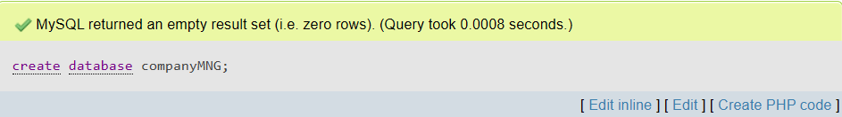
Consider the following
- Employee (E_ID, E_NAME, POST, DEPARTMENT, SALARY, ADDRESS)
- PROJECT (P_ID, P_NAME, TYPE, TIME, date, BUDGET)
- WORKS (E_NAME, P_NAME)

Create table Employee
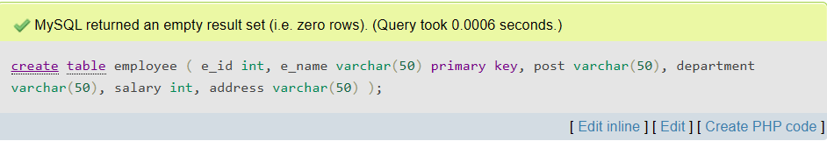
Create table Project
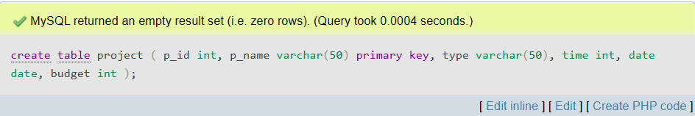
Create table Works
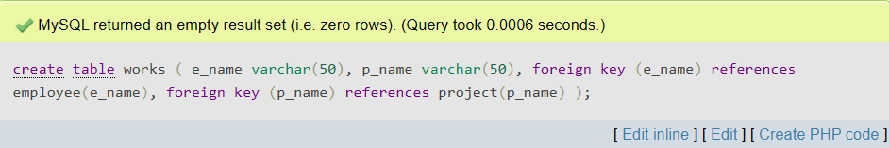

Describe Employee
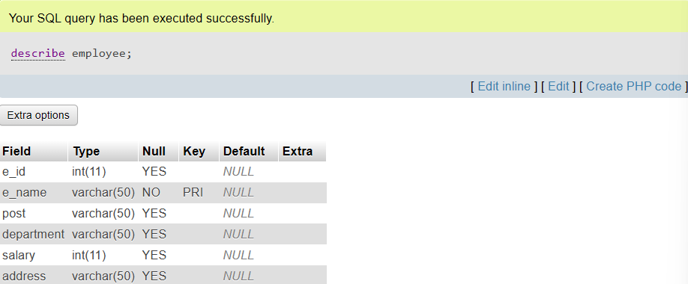
Insert Employee
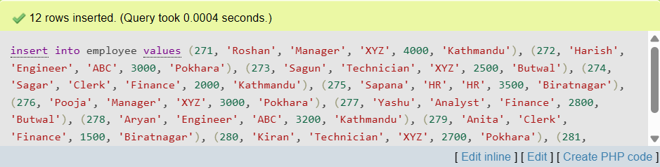
Display Employee
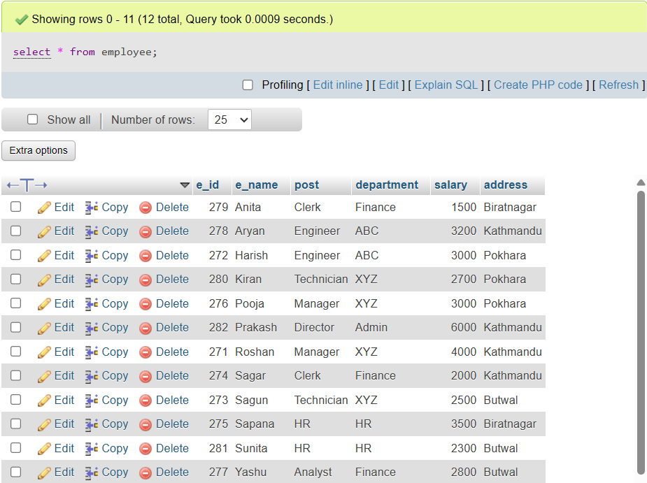
Describe Project
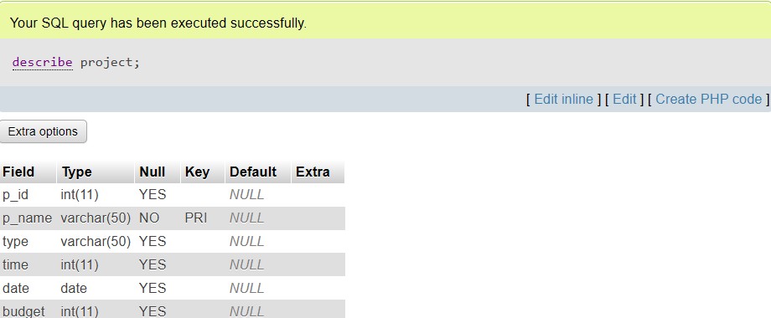
Insert Project
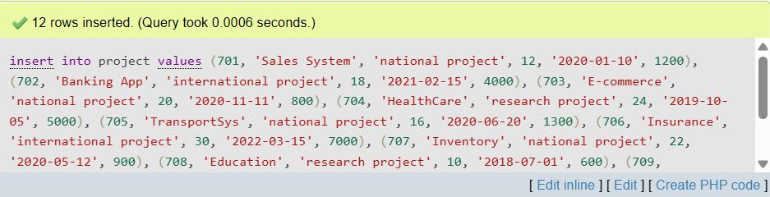
Display Project
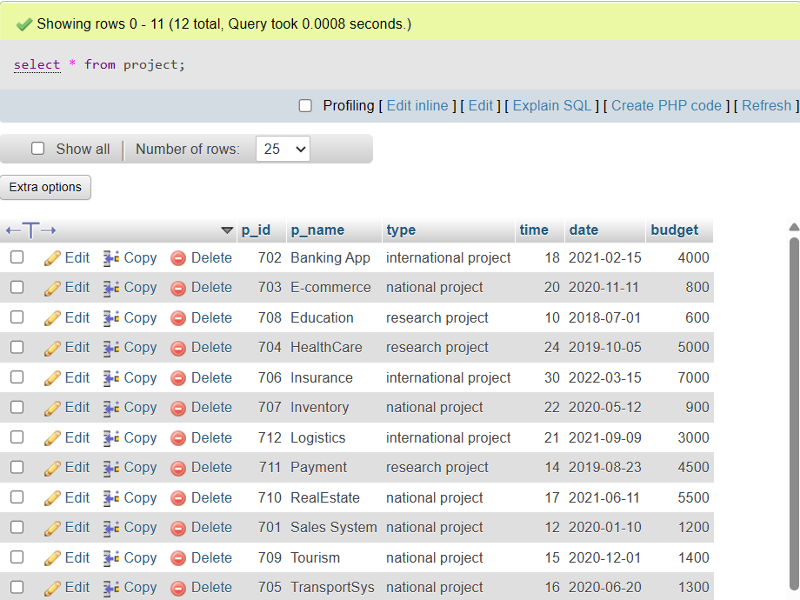
Describe Works
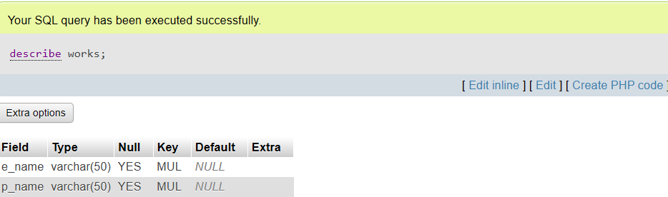
Insert Works
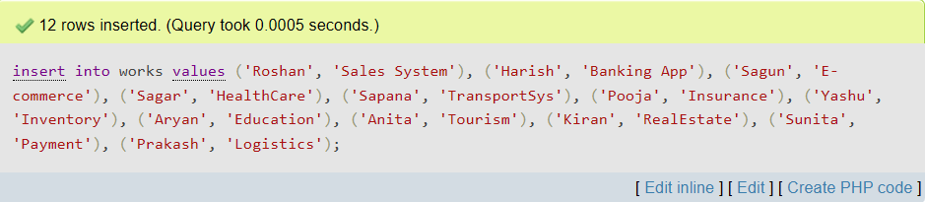
Display Works
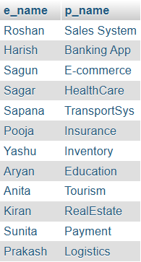

- Write SQL queries
- Display the employee name and total amount of salary where total amount is greater than 5000 and display by each employee name.
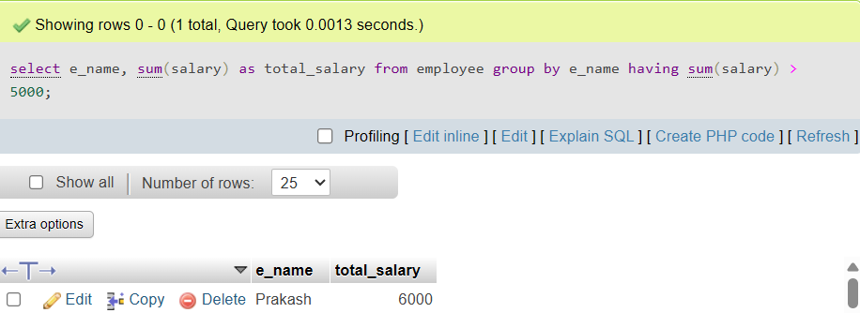
- Display e_id and department and count the number of employee with each department.
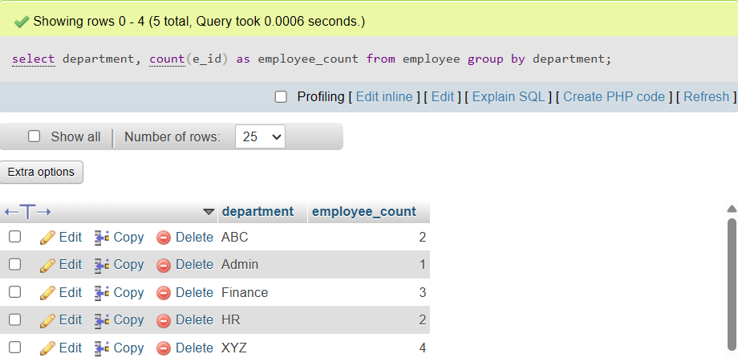
- Display employee name and project name who works on XYZ department.
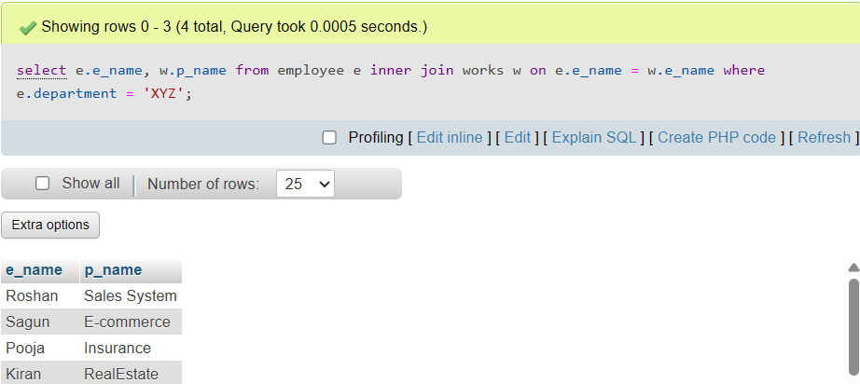
- Count the number of project budget in which budget is in between 500 and 1500.
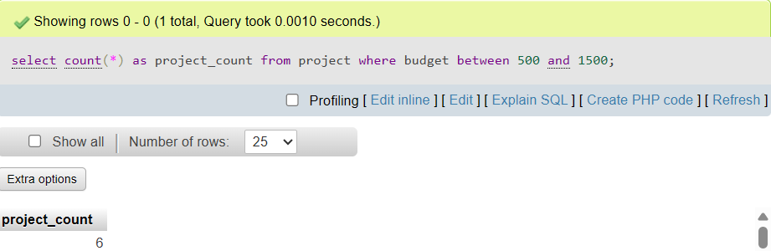
- Calculate the average salary of employee as “EMP_SALARY”.
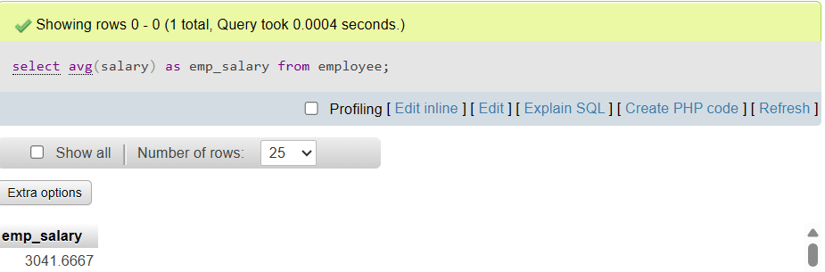
- Calculate the time of project.
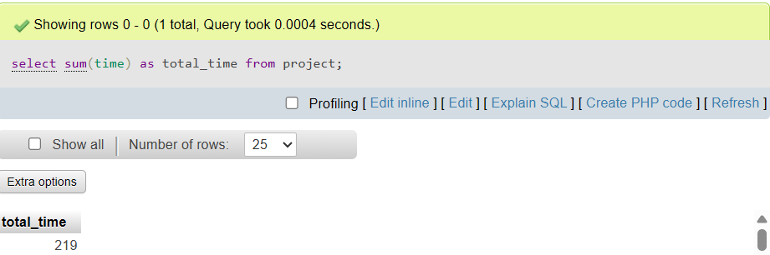
- Display the project name in which project is held before “12/12/2020”.
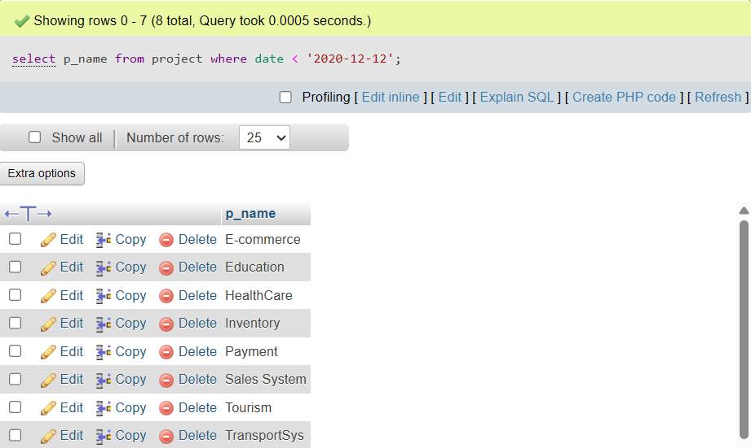
- Write SQL statement to give 25% salary increment to all employees.
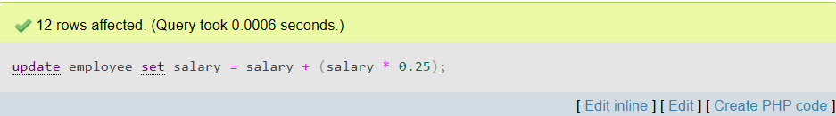
- Insert a new project as (“po1”, “sales project”, “national project”, “$5000”)
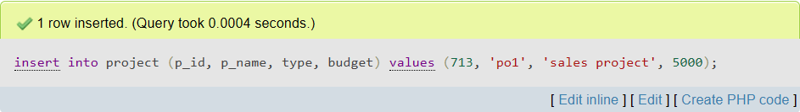
- Update the type of project “national project” with “international project”
